

Practices for Secure Software Report

Table of Contents
Document Revision History 3
Client 3
Instructions 3
Developer 4
1. Algorithm Cipher 4
2. Certificate Generation 4
3. Deploy Cipher 4
4. Secure Communications 4
5. Secondary Testing 4
6. Functional Testing 4
7. Summary 4
8. Industry Standard Best Practices 4

Document Revision History

Version | Date | Author | Comments
1.0 | 10/18/2026 | Mark Andrew Brannan | Initial release of secure practices report

Client



Instructions

Submit this completed practices for secure software report. Replace the bracketed text with the relevant information. You must document your process for writing secure communications and refactoring code that complies with software security testing protocols.

- Respond to the steps outlined below and include your findings.
- Respond using your own words. You may also choose to include images or supporting materials. If you include them, make certain to insert them in all the relevant locations in the document.
- Refer to the Project Two Guidelines and Rubric for more detailed instructions about each section of the template.

Developer
Mark Andrew Brannan

Algorithm Cipher

Algorithm Recommendation and Overview

For Artemis Financial, I recommend using SHA-256 for the data verification checksum, along with AES-256 and RSA-2048 to handle the web encryption. Artemis handles sensitive client financial plans, investments, and personal information. Because of that, we have to make sure data cannot be messed with or snooped on when people use the public web interface. SHA-256 gives us an unchangeable digital fingerprint of the data to verify integrity, while AES and RSA work together through HTTPS on port 8443 to keep the communication channel private.

Hash Functions and Bit Levels

A hash function takes regular input data and turns it into a fixed string of bits. SHA-256 belongs to the SHA-2 family and creates a 256-bit hash, which shows up as 64 hex characters. It has strong collision resistance, so two different inputs will not generate the exact same checksum, and nobody can reverse engineer the original data from the hash. For encrypting the connection, AES-256 works on 128-bit blocks with 256-bit keys, which makes it practically impossible to brute force. Older tools like MD5 at 128 bits or SHA-1 at 160 bits should not be used anymore because researchers found ways to break them with collision attacks.

Symmetric vs Asymmetric Keys and Random Numbers

Symmetric encryption like AES used the same shared key to scramble and unscramble data. It is fast and light on system resources, making it great for moving financial records back and forth between the client and server. The hard part is sharing that key safely. Asymmetric encryption like RSA fixes this by using a public key and a private key pair. We put the public key in our exported certificate file so the browser can verify our identity, while the private key stays locked in our keystore on the server. Random numbers are also critical here. Instead of basic random functions that follow predictable patterns, security tools use cryptographically strong random number generators so keys and session tokens cannot be guessed.

History and Modern Encryption Standards

Encryption standards have evolved significantly over the decades to keep pace with growing computing power. The Data Encryption Standard (DES) was widely used in the 70’s, but its 56-bit keylength eventually made it vulnerable to brute force attacks. Triple DES was introduced as a temporary fix, but its slow processing speed and small 64-bit block size led NIST to establish AES as the primary standard in 2001. As mentioned earlier, hashing algorithms went through a similar shift when MD5 and SHA-1 were retired after researchers proved they were vulnerable to collision attacks. Today, secure web applications rely on SHA-256 alongside current TLS protocols that retire outdated ciphers and protect session traffic. Implementing SHA-256 with HTTPS gives Artemis Financial a solid foundation that aligns directly with modern security expectations.

Certificate Generation

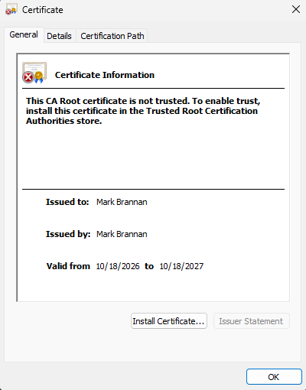

Deploy Cipher

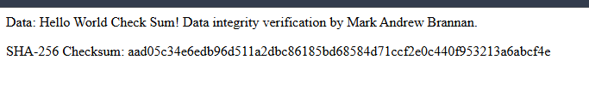

Secure Communications

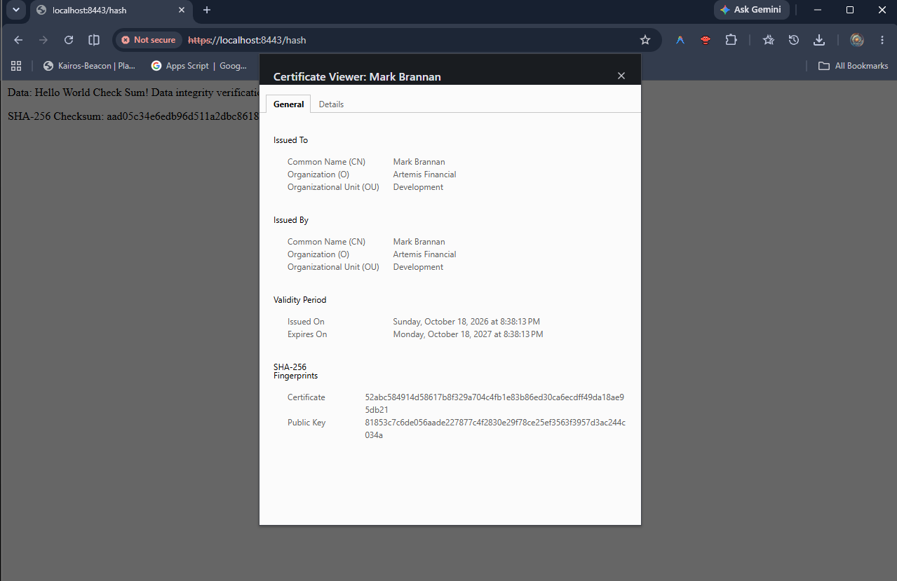

Secondary Testing

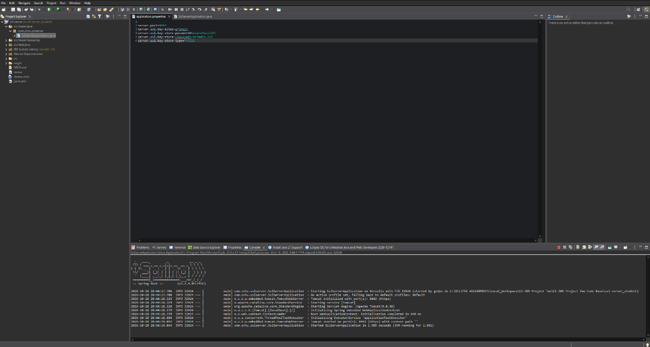

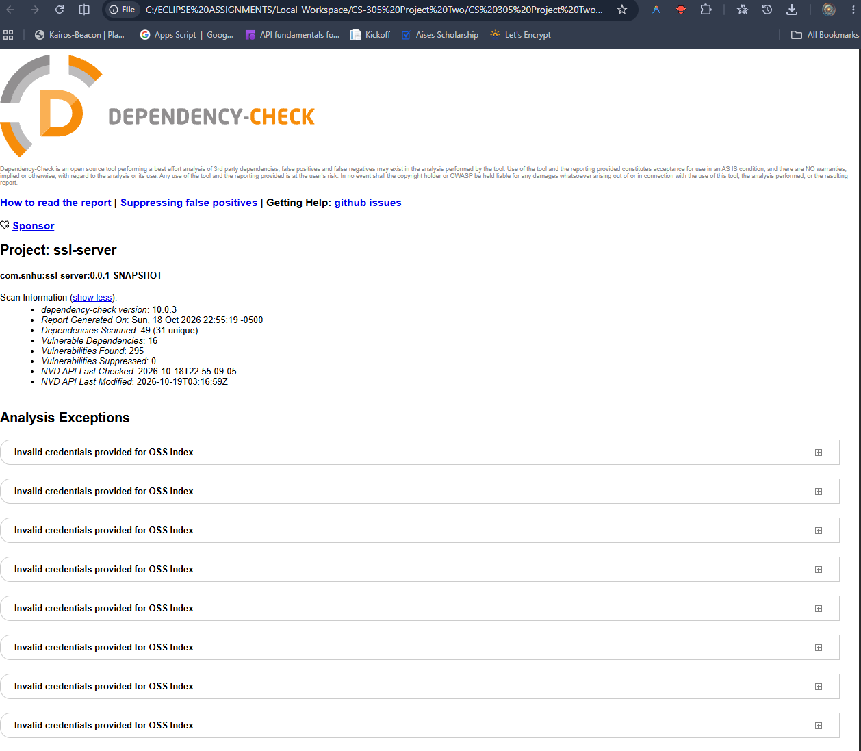

Functional Testing

Manual Code Review and Vulnerability Analysis

A manual security review of the original codebase identified key syntactical, logical, and architectural security vulnerabilities. Syntactically, the starter project was valid Java, but logically it lacked any mapped endpoints or business logic to handle incoming client requests. Architecturally, the application had major security vulnerabilities because network communications were unencrypted, exposing data to man in the middle interception and packet sniffing. Additionally, the application lacked data integrity verification, meaning altered financial records would pass undetected. I refactored SslServerApplication.java to implement a REST endpoint generating a SHA-256 cryptographic checksum and configured application.properties to enforce TLS encryption on port 8443. As shown in the screenshot below, the refactored code executes without syntactical or logical errors and initializes Tomcat cleanly on HTTPS.

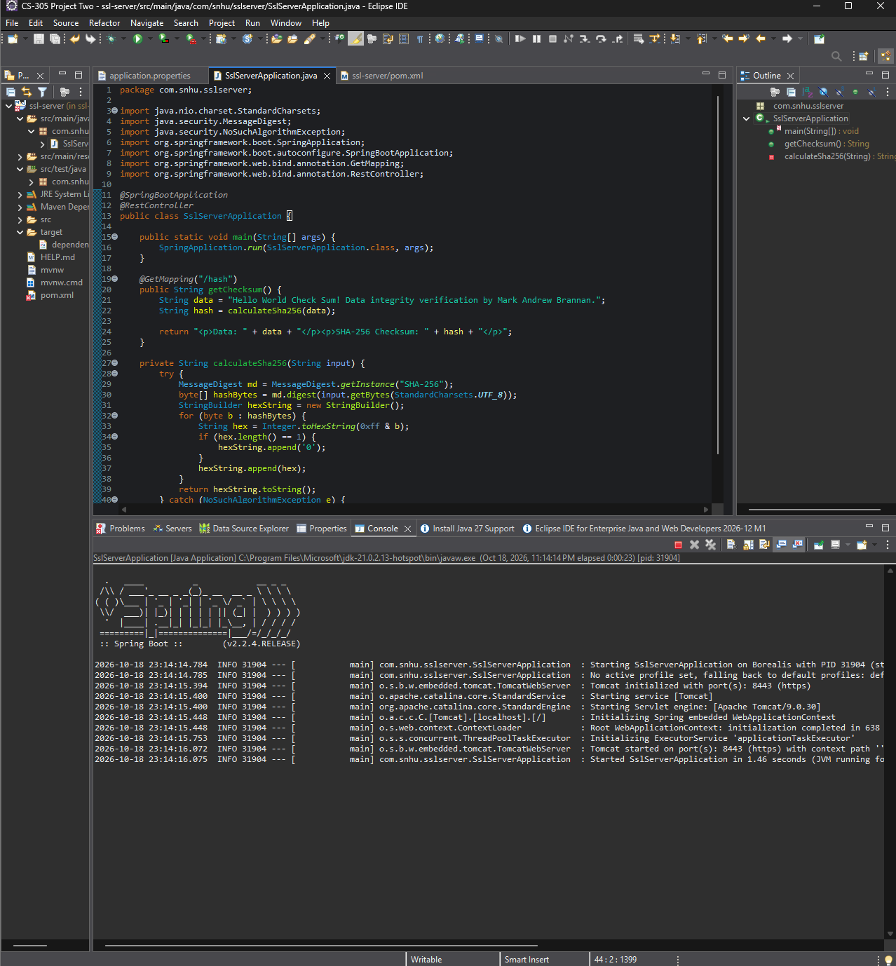

Summary

Vulnerability Assessment and Addressed Security Areas

Looking at the Vulnerability Assessment Process Flow diagram, our refactoring work directly tackled multiple core security pillars, especially Cryptography, Client/Server communication, APIs, and Code Error handling. Previously, the Artemis Financial web application lacked transport layer protection and had no mechanism to verify whether files or transactions were modified during transit. We resolved the Cryptography and Client/Server areas by implementing TLS encryption over HTTPS on port 8443, locking down client communications so attackers cannot eavesdrop on sensitive financial data.
On the API side, we built a dedicated /hash GET endpoint that handles requests securely and returns an unambiguous data integrity check. For error handling, we wrapped our cryptographic routines inside a clean try-catch block catching NoSuchAlgorithmException , making sure that any internal failure fails safely without crashing the underlying service or dumping raw stack traces back to an end user.

Process for Adding Layers of Security

Securing this application followed a clear defense-in-depth workflow. The first layer started at the network and transport layer by generating an RSA 2048-bit self-signed certificate, configuring a PKCS12 keystore, and enforcing HTTPS in application.properties. This ensures that every byte leaving or entering the server is encrypted in flight. The second layer focused on data integrity by introducing SHA-256 hashing at the application layer, giving Artemis Financial a dependable checksum tool to prove that stored and transferred records remain untouched. The final layer brought in static testing through OWASP dependency-check in Maven, which scans every project library against known CVE databases to guarantee that third-party code does not introduce backdoors or exploitable bugs into our stack.

Industry Standard Best Practices

Maintaining Existing Application Security

To protect the existing code while adding new features, I stuck closely to established secure coding standards like the principle of least privilege and strict defensive programming. Instead of modifying core Spring Boot dependencies or weakening existing configuration parameters, I isolated the new checksum functionality inside a private helper method that converts byte digests into standard hexadecimal format using immutable strings. I also made sure that internal credentials and keystore files remain protected by referencing the keystore directly via the Spring classpath rather than exposing absolute file paths on the host system. By using standardized Java security packages like java.security.MessageDigest rather than trying to build a custom hashing algorithm, the application relies exclusively on thoroughly vetted, battle tested cryptographic primitives.

Business Value to Artemis Financial

Applying these secure coding practices creates massive value for Artemis Financial by safeguarding customer trust and preventing catastrophic financial loss. Financial consulting firms are high-value targets for identity theft, fraud, and corporate espionage because they store retirement plans, investment portfolios, and tax documentation. A single data breach or man-in-the-middle attack can lead to severe regulatory fines, lawsuits, and irreversible reputational damage. By investing in transport security, data verification checksums, and automated dependency scanning, Artemis Financial protects its clients, meets financial compliance standards, and preserves its operational bottom line over the long haul.

